STUDENT ROOMATE FINDER WITH COMPATIBILITY MATCHING
Micro project report
Submitted in partial fulfillment for the award of the degree
of
BACHELOR OF TECHNOLOGY
in
ARTIFICIAL INTELLIGENCE AND MACHINE LEARNING
of
APJ ABDUL KALAM TECHNOLOGICAL UNIVERSITY
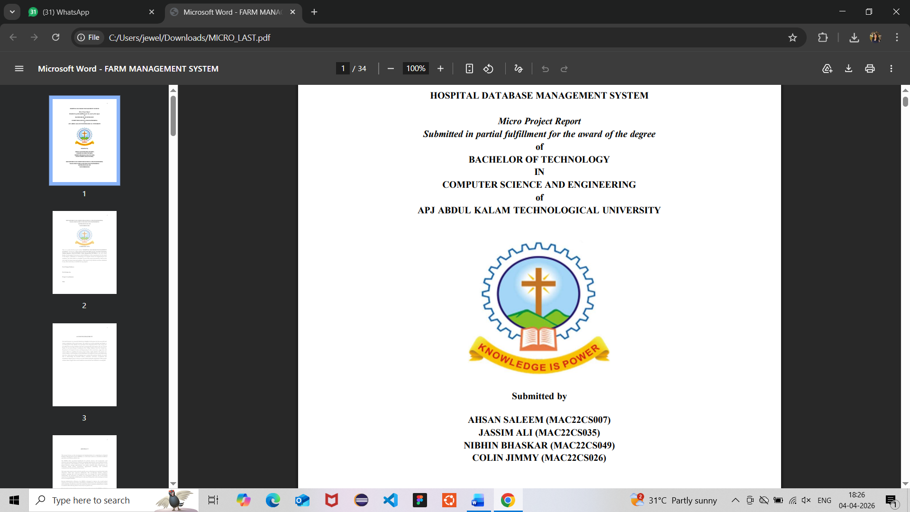
DEPARTMENT OF COMPUTER SCIENCE AND ENGINEERING
MAR ATHANASIUS COLLEGE OF ENGINEERING
KOTHAMANGALAM
APRIL 2026
Submitted By
Jesbin Shaju ( MAC24AIM040)
Jess Johnson (MAC24AIM041)
Jewel Thomas (MAC24AIM042)
K M Mohammed Ansaf ( MAC24AIM043)

DEPARTMENT OF COMPUTER SCIENCE AND ENGINEERING
MAR ATHANASIUS COLLEGE OF ENGINEERING
KOTHAMANGALAM
APRIL 2026


CERTIFICATE
this is to certify that the report entitled “STUDENT ROOMATE FINDER AND COMPATIBILITY MATCHER” submitted by JESBIN SHAJU, JESS JOHNSON , JEWEL THOMAS AND K MOHAMMED ANSAF to the APJ Abdul Kalam Technological University in partial fulfilment of the requirements for the award of the degree of Bachelor of Technology in Artificial Intelligence And Machine Learning for the academic year 2025-26 in a Bonafide record of the project presented by them for the year under out supervision and guidance. This report in any form has not been submitted to ant other university or institute for any purpose

Prof Anu Eldho

Prof Sruthi Moncy

Project coordinators
Date

CONTENTS

- ACKNOWLEDGEMENT
- ABSTRACT
- PROBLEM STATEMENT
- INTRODUCTION
- PROPOSED SOLUTION
- DATABASE DESIGN
- TABLE DESIGN
- IMPLEMENTATION DETAILS
- RESULTS
- SDG MAPPING
- CONCLUSION
- REFERENCES

ACKNOWLEDGEMENT

First and foremost we sincerely thank God Almighty for his grace for the successful and timely completion of the micro project. We express our sincere gratitude and thanks to our principal Dr Bos Mathew Jos and Head of the department Prof. Joby George for providing the necessary facilities and their encouragement and support . we owe special thanks to our microproject coordinators Prof Anu Eldho and Prof Sruthi Moncy for their corrections ,suggestions and sincere thanks to Prof Preethi for guiding us throughout the project.
We finally would like to acknowledge the heartfelt efforts , comments , criticism, co-operations and tremendous support given to me by our friends during the preparation of the project without whose support this work would have been all more difficult to accomplish

ABSTRACT

The Student Roommate & PG Finder with Compatibility Matching system is a database-driven web application designed to help students find suitable accommodation and compatible roommates when relocating to new cities. The system allows users to create profiles based on preferences such as budget, food habits, sleep schedule, and cleanliness. Using SQL-based logic, it matches students with compatible roommates and suggests relevant PG accommodations.
The application is developed using TypeScript for the frontend and PostgreSQL for backend database management. Various DBMS concepts such as DDL, DML, DQL, joins, and nested queries are used to ensure efficient data handling and retrieval of information.
Additional features include rent splitting, complaint tracking, and a review system to enhance transparency and user experience. The system also ensures data integrity using constraints, triggers, and transactions. Overall, the project demonstrates the practical application of database management concepts in solving real-world accommodation problems while improving user convenience and efficiency.

PROBLEM STATEMENT

Students relocating to new cities for higher education often face significant challenges in finding suitable accommodation and compatible roommates. Existing methods of searching for Paying Guest (PG) accommodations rely heavily on informal sources such as brokers, advertisements, or online listings, which are often unreliable, unstructured, and time-consuming. These methods do not provide personalized results based on individual preferences such as budget, lifestyle habits, or cleanliness.
Moreover, there is no integrated system that combines both accommodation search and roommate compatibility matching. As a result, students frequently end up with mismatched roommates or inconvenient living conditions, leading to discomfort and reduced productivity. The lack of transparency in reviews and absence of a proper complaint mechanism further adds to the problem.
Therefore, there is a need for a centralized, database-driven system that can efficiently manage accommodation data, match students based on compatibility, and provide a reliable platform for searching, reviewing, and managing PG accommodations and shared living arrangements.

INTRODUCTION

In today’s rapidly growing urban environment, students frequently relocate to different cities in pursuit of higher education. One of the major challenges they face during this transition is finding suitable accommodation and compatible roommates. Traditional methods of searching for Paying Guest (PG) accommodations, such as local brokers, advertisements, or informal networks, are often time-consuming, unreliable, and lack transparency. Additionally, the absence of compatibility consideration between roommates can lead to discomfort and conflicts in shared living spaces.
With the advancement of technology, database-driven applications have become essential in managing and organizing large amounts of data efficiently. This project, titled Student Roommate & PG Finder with Compatibility Matching, aims to address these challenges by providing a centralized platform that integrates accommodation search with roommate matching. The system allows students to create profiles based on their preferences such as budget, food habits, sleep schedule, and cleanliness, enabling better compatibility assessment.
The application is developed using TypeScript for the frontend and PostgreSQL for backend database management. It utilizes core Database Management System (DBMS) concepts such as data definition, data manipulation, and data querying to store, manage, and retrieve information efficiently. Advanced features like joins, nested queries, triggers, and transactions are implemented to ensure data consistency and reliable system performance.
Furthermore, the system includes additional functionalities such as rent splitting, complaint management, and review mechanisms, which enhance user experience and promote transparency. By combining efficient data handling with user-centric design, this project demonstrates how DBMS concepts can be applied to solve real-world problems effectively and improve the overall accommodation search experience for students.

PROPOSED SOLUTION

The proposed system is a comprehensive database-driven web application designed to simplify the process of finding suitable accommodation and compatible roommates. It provides two main perspectives: the Student View and the Admin (Landlord) View, each with clearly defined functionalities to ensure smooth operation of the system.

Student View
From the student’s perspective, the system is designed to provide a seamless and personalized experience:
1. Registration and Profile Creation:
Students begin by registering into the system and creating a detailed profile. They provide essential information such as name, contact details, budget, food habits (vegetarian/non-vegetarian), sleep schedule, study hours, and cleanliness preferences. This data is stored in the database and forms the basis for further matching.
2. Compatibility-Based Roommate Matching:
The system analyzes the stored preferences using SQL queries and logical conditions to calculate compatibility between students. Based on similarity in habits and preferences, the system suggests suitable roommates, reducing the chances of conflicts in shared living.
3. Booking Management:
Students can select a PG and proceed with booking. The system records booking details and ensures data consistency using transaction control mechanisms such as COMMIT and ROLLBACK.
4. Complaint Handling:
If students face issues related to accommodation or roommates, they can raise complaints through the system. These complaints are stored in the database and forwarded to the admin for resolution.
7. Rent Splitting:
For shared accommodations, the system provides a rent-splitting feature that divides expenses among roommates, making financial management easier and more organized.

Admin / Landlord View
From the admin or landlord perspective, the system provides tools for managing and controlling the platform:
1. User Management:
Admins can monitor registered users, verify their details, and manage accounts. They can restrict or remove users if necessary, ensuring system security and reliability.
2. PG Listing Management:
Admins or landlords can add new PG accommodations by entering details such as rent, amenities, and availability. They can also update or delete existing listings to keep the information accurate and up-to-date.
3. Booking Oversight:
Admins can view and manage booking records, ensuring that accommodation availability is properly maintained and no conflicts occur.
4. Complaint Resolution:
Admins are responsible for handling complaints raised by students. They review the issues and take necessary actions to resolve them, ensuring user satisfaction.
6. Data Integrity and Security:
Admins ensure that the database remains consistent and secure by enforcing constraints, managing access control, and overseeing transactions. Role-based access ensures that only authorized users can perform specific actions.

System Implementation Overview
The system is implemented using TypeScript for the frontend to provide an interactive and responsive user interface, and PostgreSQL for backend database management. Core DBMS concepts such as DDL, DML, DQL, joins, nested queries, triggers, and transactions are used to handle data efficiently. The integration of these technologies ensures that the system is scalable, reliable, and capable of handling multiple users simultaneously.

IMPLEMENTATION DETAILS
IMPLEMENTATION DETAILS
The Student Roommate & PG Finder with Compatibility Matching system is implemented using a layered architecture consisting of frontend, backend, and database components. The system is designed to ensure efficient data processing, user interaction, and reliable performance in a multi-user environment.

1. System Requirements and Specifications
Hardware Requirements:
- Processor: Intel i3 or above
- RAM: Minimum 4 GB (8 GB recommended)
- Storage: At least 500 MB free space
- System Type: 64-bit architecture
Software Requirements:
- Operating System: Windows / Linux / macOS
- Frontend: TypeScript, HTML, CSS
- Backend / Database: PostgreSQL
- Tools: VS Code / any IDE, Web Browser (Chrome, Edge, etc.)
System Specifications:
- Architecture: Client–Server model
- Database Type: Relational Database (PostgreSQL)
- Users: Students and Admin/Landlord
- Connectivity: Localhost or network-based access

2. Frontend Implementation (TypeScript)
The frontend of the system is developed using TypeScript along with HTML and CSS to create an interactive and user-friendly interface. TypeScript enhances JavaScript by providing type safety and better code structure, making the application more maintainable and scalable.
The frontend consists of multiple modules such as:
- Registration and Login Pages: Used for user authentication and profile creation
- Dashboard Interface: Displays options for PG search, roommate matching, and user actions
- Search and Display Pages: Show PG listings and roommate suggestions dynamically
- Forms: Used for booking, reviews, and complaint submission
User inputs are validated at the client side using TypeScript to ensure correct data entry before sending it to the backend. The frontend communicates with the database through structured queries and displays results in an organized format.

3. Backend and Database Implementation (PostgreSQL)
The backend of the system is primarily database-driven using PostgreSQL. It is responsible for storing, managing, and retrieving data efficiently.
Database
The system includes several tables such as:
- STUDENT (stores user details and preferences)
- LANDLORD (stores landlord information)
- PG_DETAILS (stores accommodation details)
- BOOKING (handles reservation records)
- REVIEW (stores ratings and feedback)
- COMPLAINT (records user issues)
- ROOMMATE_MATCH (stores compatibility results)
Key DBMS Features Used:
- DDL (Data Definition Language): Used to create and define tables with constraints like primary keys and foreign keys
- DML (Data Manipulation Language): Used to insert, update, and delete records
- DQL (Data Query Language): Used for retrieving data using SELECT queries
- Joins and Nested Queries: Used for combining data from multiple tables and implementing matching logic
- Triggers: Automatically update fields such as timestamps and complaint counts

- Functions and Procedures: Used to calculate compatibility scores and handle business logic
- Transactions (TCL): Ensure data consistency during booking operations using COMMIT and ROLLBACK

4. Working Mechanism
When a user interacts with the system, the request is processed through the frontend and passed to the database. PostgreSQL executes the required SQL queries and returns the results, which are then displayed to the user. The system ensures efficient communication between components using structured query execution.

5. OS-Level Support
At the operating system level, the system utilizes:
- Process Management: Handles multiple user requests simultaneously
- Memory Management: Allocates memory for query execution and caching
- File System: Stores database files securely
- Concurrency Control: Prevents conflicts during simultaneous data access
- Security Mechanisms: Ensures data protection through access control

6. Performance and Scalability
The system is designed to handle multiple users efficiently. Indexing is applied to frequently accessed fields to improve query performance. Proper normalization reduces redundancy and enhances data integrity, making the system scalable for future expansion.

SYSTEM IMPLEMENTATION

The Student Roommate & PG Finder with Compatibility Matching system is implemented using a modular, database-driven approach following a client–server architecture. The frontend is developed using TypeScript along with HTML and CSS to provide an interactive user interface, while PostgreSQL is used as the backend database for efficient data storage and processing.
The system is divided into key modules including user registration and login, profile management, roommate matching, PG listing and search, booking, reviews, complaint handling, and rent splitting. Each module interacts with the database through SQL queries to perform operations such as inserting, updating, and retrieving data.
The roommate matching feature is implemented using SQL conditions that compare user preferences to generate compatibility results. PG search and display are handled using SELECT queries and joins for efficient data retrieval. Booking operations are managed using transaction control mechanisms like COMMIT and ROLLBACK to ensure data consistency.
Advanced database features such as triggers and functions are used to automate processes like updating timestamps and calculating values. Proper constraints and relationships are maintained to ensure data integrity and avoid redundancy.
Overall, the system integrates frontend interactivity with backend database operations to provide a reliable, efficient, and user-friendly platform for managing student accommodation and roommate matching.

EXPERIMENTAL RESULTS
The Student Roommate & PG Finder with Compatibility Matching system was successfully implemented and tested using a variety of sample datasets to evaluate its overall performance, accuracy, and reliability. The system effectively handled all major functionalities, including user registration, profile creation, PG listing, roommate matching, booking, reviews, complaints, and rent management.
The roommate compatibility feature demonstrated accurate and meaningful results by analyzing multiple user preferences such as budget, food habits, sleep schedule, study hours, and cleanliness. The use of SQL queries with conditional logic ensured that the matching process was efficient and relevant, reducing the chances of incompatible pairings. The results were generated quickly, indicating optimized query execution.
The PG search and retrieval functionality performed efficiently even with an increased number of records. SQL operations such as SELECT queries, joins, and filtering conditions were used to fetch appropriate results with minimal response time. This shows that the system is scalable and capable of handling larger datasets without significant performance degradation.
Transaction-based operations, especially booking and rent-related processes, were tested thoroughly. The implementation of COMMIT and ROLLBACK ensured that incomplete or failed transactions did not affect the database, maintaining consistency and reliability. This confirmed the robustness of transaction control mechanisms in real-time scenarios.
Triggers and functions were also tested to verify automation within the system. For instance, timestamps were automatically updated when reviews or complaints were added, and calculated values were generated without manual intervention. This reduced redundancy and improved system efficiency.
From an operational perspective, the system handled multiple user interactions smoothly, demonstrating effective concurrency control. There were no data conflicts or inconsistencies observed during simultaneous operations, indicating proper synchronization and resource management.
Data integrity was maintained throughout the system using primary keys, foreign keys, and constraints. The database design followed normalization principles, reducing redundancy and ensuring efficient storage. Indexing further improved performance by speeding up frequently executed queries.

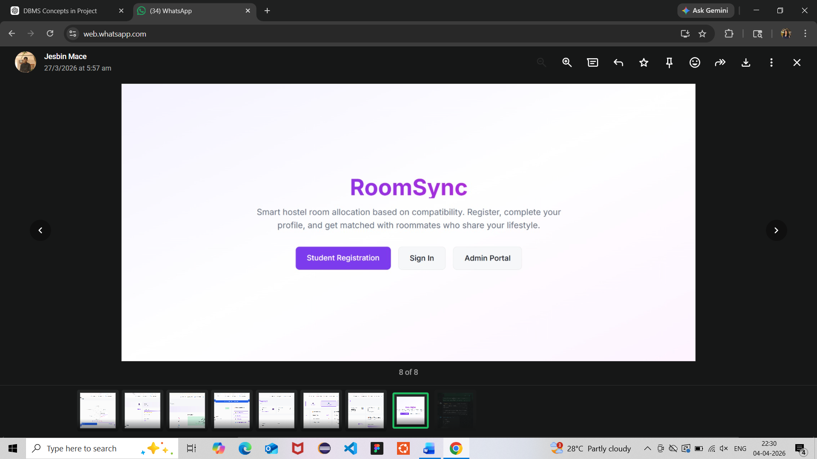
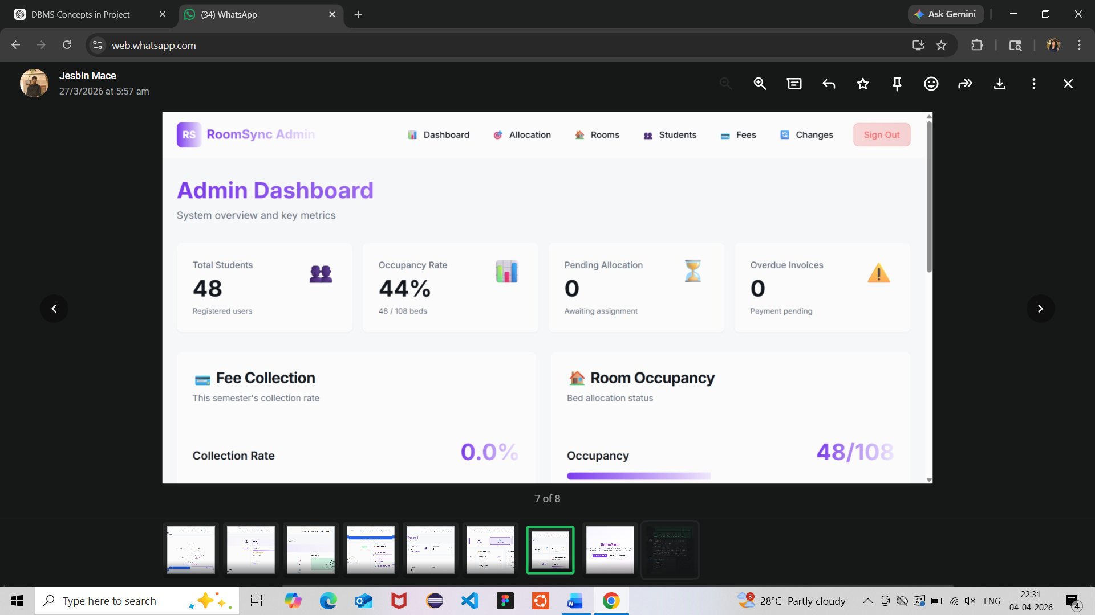

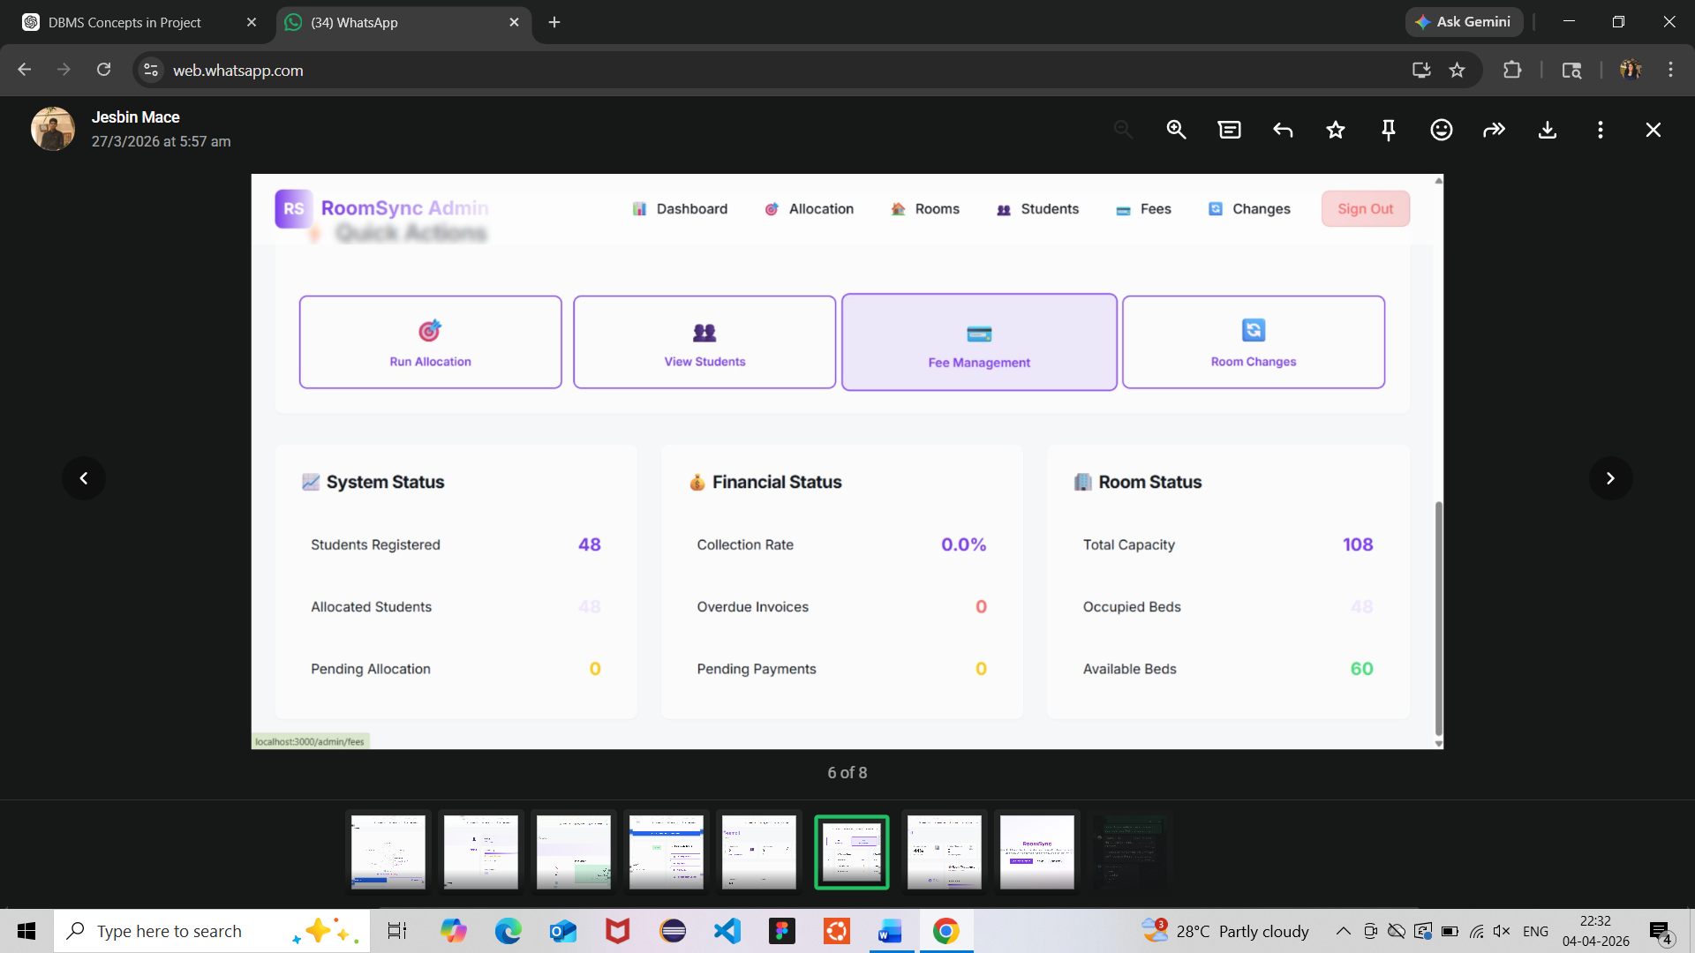
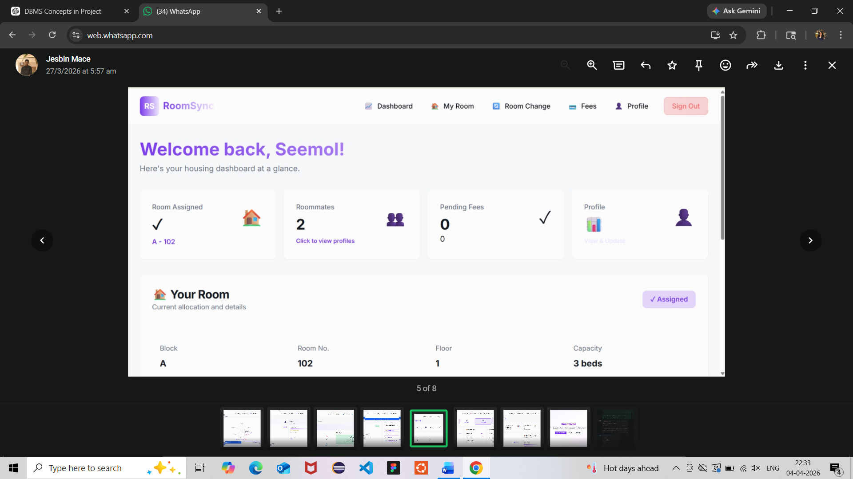

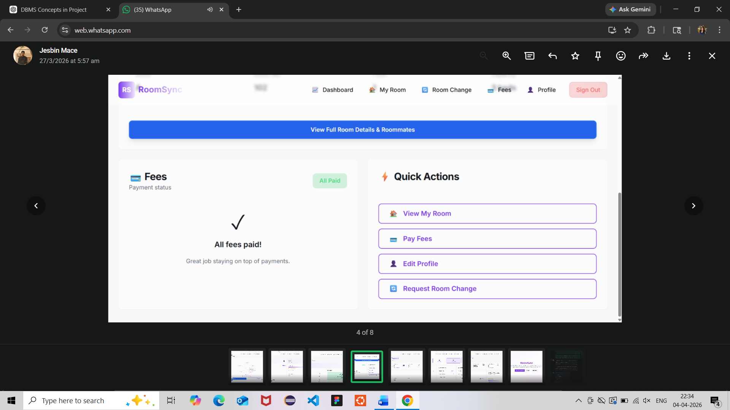
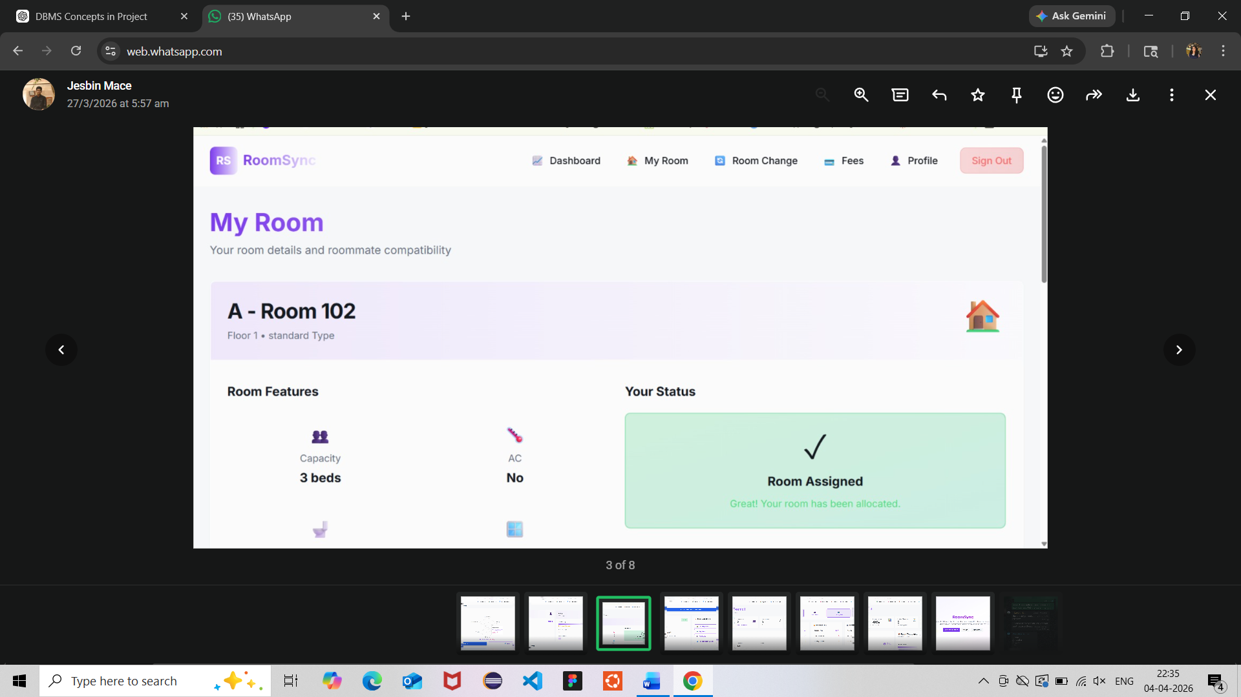

SDG MAPPING

The Student Roommate & PG Finder with Compatibility Matching system aligns with the Sustainable Development Goals (SDGs) proposed by the United Nations by addressing challenges related to student accommodation and urban living.
The project primarily supports SDG 11 – Sustainable Cities and Communities by improving access to safe, affordable, and organized housing for students. It helps in better utilization of available PG accommodations and promotes efficient urban living.
It also contributes to SDG 4 – Quality Education by reducing the stress and time students spend searching for accommodation, allowing them to focus more on their academic activities and overall well-being.
Additionally, the system supports SDG 8 – Decent Work and Economic Growth by providing landlords with a structured platform to list their properties and connect with potential tenants, thereby supporting small-scale rental businesses.
Overall, the project demonstrates how technology and database systems can contribute to sustainable development by improving accessibility, efficiency, and quality of living for students.

CONCLUSION

The Student Roommate & PG Finder with Compatibility Matching system successfully demonstrates the practical application of Database Management System concepts in solving real-world problems faced by students. The project provides an efficient platform for finding suitable accommodation and compatible roommates based on user preferences, improving convenience and decision-making.
By integrating core DBMS concepts such as SQL queries, normalization, triggers, functions, and transaction management, the system ensures data integrity, reliability, and efficient performance. The use of a structured database enables organized storage and quick retrieval of information, making the system scalable and user-friendly.
Additional features such as roommate matching, review systems, complaint handling, and rent splitting enhance the overall functionality and usability of the platform. The system also ensures smooth handling of multiple user requests, demonstrating effective resource management and concurrency control.
Overall, this project highlights how database-driven applications can be effectively used to address everyday challenges, providing a reliable, efficient, and practical solution for student accommodation management.

